

**Batch # 3**

**Internship**

**Finance**

**Submitted to:** Digital Empowerment Network

**Submitted By:** Malaika Tariq

**CID: DEN8466**

**Task # 6**

* Analysis of a small business’s **Statement of Changes in Equity (SOCIE)** for the previous quarter and use it to forecast changes**over a financial year.**
* **Analyze the changes in equity**:
* What is the business’s **profitability**? (Use the net income to assess this.)
* How are **owner contributions** and **withdrawals** impacting the equity?
* Has the equity increased or decreased over the quarter? Why?

**Statement of Changes in Equity (SOCIE)**

**ABC Company Limited, Pakistan**

For the half year ended June 30, 2024

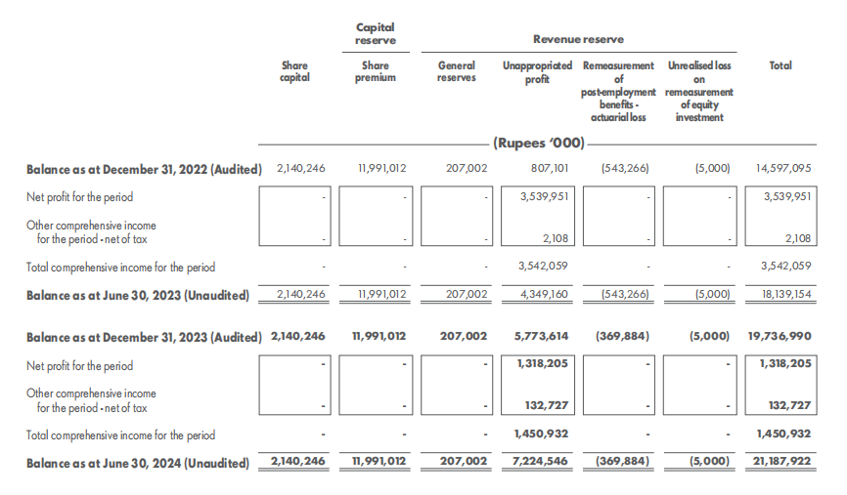

**Analyze the changes in equity**

**1. Business Profitability**

* **Net Profit for the period (June 30, 2023):** The business reported a **net profit of 3,539,951 ('000 Rupees)** for the period ending June 30, 2023.
* **Net Profit for the period (June 30, 2024):** The business reported a **net profit of 1,318,205 ('000 Rupees)** for the period ending June 30, 2024.

Thus, the business remains profitable across both periods, though there was a decrease in net profit from **3,539,951** to **1,318,205** between these two dates. This suggests that while the business is profitable, its profitability has declined during this period.

**2. Owner Contributions and Withdrawals Impacting Equity**

* There is no indication of new contributions by owners (such as increases in share capital or share premium), nor any significant withdrawals (like dividends), meaning the equity changes are primarily due to profit retention and other comprehensive income or losses.

Specifically:

* + **Share Capital** and **Share Premium** remain constant at **2,140,246** and **11,991,012** respectively, showing no new owner contributions.
  + No withdrawals or significant reductions that would reduce equity appear to be present in the form of dividends or withdrawals.

**3. Equity Changes Over the Quarter**

* **Balance as at June 30, 2023:** The total equity was **18,139,154 ('000 Rupees)**.
* **Balance as at June 30, 2024:** The total equity increased to **21,187,922 ('000 Rupees)**.

This represents an increase in equity of **3,048,768 ('000 Rupees)** over the quarter.

In summary, the business's profitability has decreased slightly but remains positive, and equity has grown due to retained profits and other comprehensive income. There were no significant owner contributions or withdrawals affecting equity during the period.